MILESTONE 2: GOING DEEPER ON DESIGN
SCENARIOS AND STORYBOARDS

User need statements:
1. Emily, a new art student, needs guidance on giving peer feedback in order to feel more confident in leaving comments critiquing her classmates despite being new to the process

2. Midori, a fine art student, needs to engage with her peer feedback partner more in order to get more detailed feedback through their conversations.

3. Lee, a UX design student needs to leave recorded commentary in order to add more clarity and depth to his feedback without worrying about having his words and tone misinterpreted.

SCENARIOS:

Fret:
- First time giving/receiving feedback, needs guidelines. > Fret is giving feedback to a fellow classmate for the first time, and feels overwhelmed. They don’t know what to comment on or how they should phrase their feedback. They look for guidelines to help them figure out how to phrase their comments. They refer back to the guidelines before, during, and after writing to be sure they’re doing it well.
  - How to find feedback guidelines easily, and make them easy to access
- Targeting feedback to the right areas. > Fret feels like they don’t get the kind of feedback that is helpful to them. They are looking to improve specific parts of their work, but nobody is leaving feedback on the parts they are most nervous about. They want to get people to give them the feedback in the areas they want.
  - Figuring out specific feedback they want to receive (for easier communication)

Seasoned:
- Converse more with partner. > Seasoned is really hoping to build a long term working partnership with the classmate they’re giving feedback to, but with all the work they have to do, leaving detailed, thoughtful feedback just keeps slipping their mind. They want to know when their partner responds to their feedback, and remember when it’s their turn to leave feedback.
  - Process of giving and receiving feedback
- Choose how to leave feedback. > Seasoned struggles to understand written comments tone, and has been meeting up in person with their partner. However, their partner is now on a trip, and has suggested leaving voice notes for each other instead. Seasoned is excited at the thought of leaving voice commentary, but still wants to make it easy for their partner to see where they are referring to.
  - Choosing the type of feedback they want to leave (text, voice note etc.)

FORMAT:
- Initial Situation - Who is our user (persona), and what is their problem?
- Steps - What actions do they take to find a solution? How do they feel when they’re taking these steps?
- Outcome - What is the end state? How do they feel at the end, and what have they accomplished?

Storyboards:
- 5-6 scenes for each storyboard

INDIVIDUAL USER SCENARIOS + STORYBOARDS:

Scenario: Fret frets about how to give feedback.

Fret, a brand new design student, is leaving comments on a partner’s poster design.[1] They are really stressed out about how they should comment - if they’re overly critical and nitpicky, their partner might think they’re mean, but if they are too shallow or comment on the wrong thing, then they might think they’re not good enough for the class.[2]

Fret remembers the professor gave the class guidelines on what to focus on when commenting. As they think about where it was in Brightspace, they notice the “review guidelines” call to action button on the screen, and click on it.[3] They find the assignment information and the teacher’s guidelines on feedback, and notice another section with tips on how to phrase constructive feedback.[4]

When they go back to the poster, the guidelines stay open. Fret starts commenting, glancing over and referring back to the feedback guidelines and tips as they write.[5] Once they finish, they give the guidelines one last look before closing the section. They feel a lot more confident about the comments they’re leaving - though they add a few extra emojis and compliments to keep the vibe positive before submitting their feedback. [6]

Storyboard:
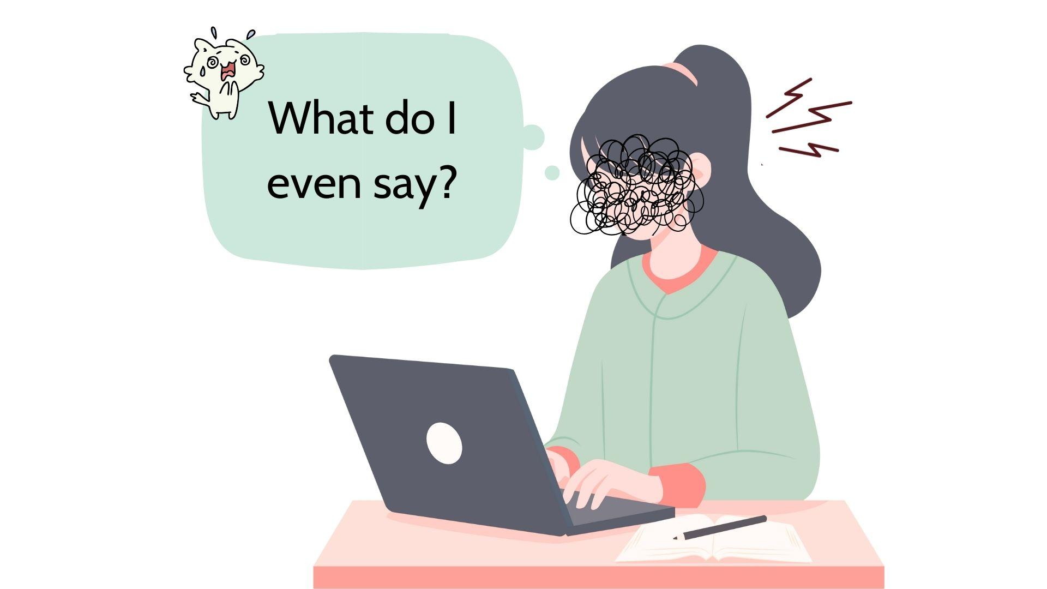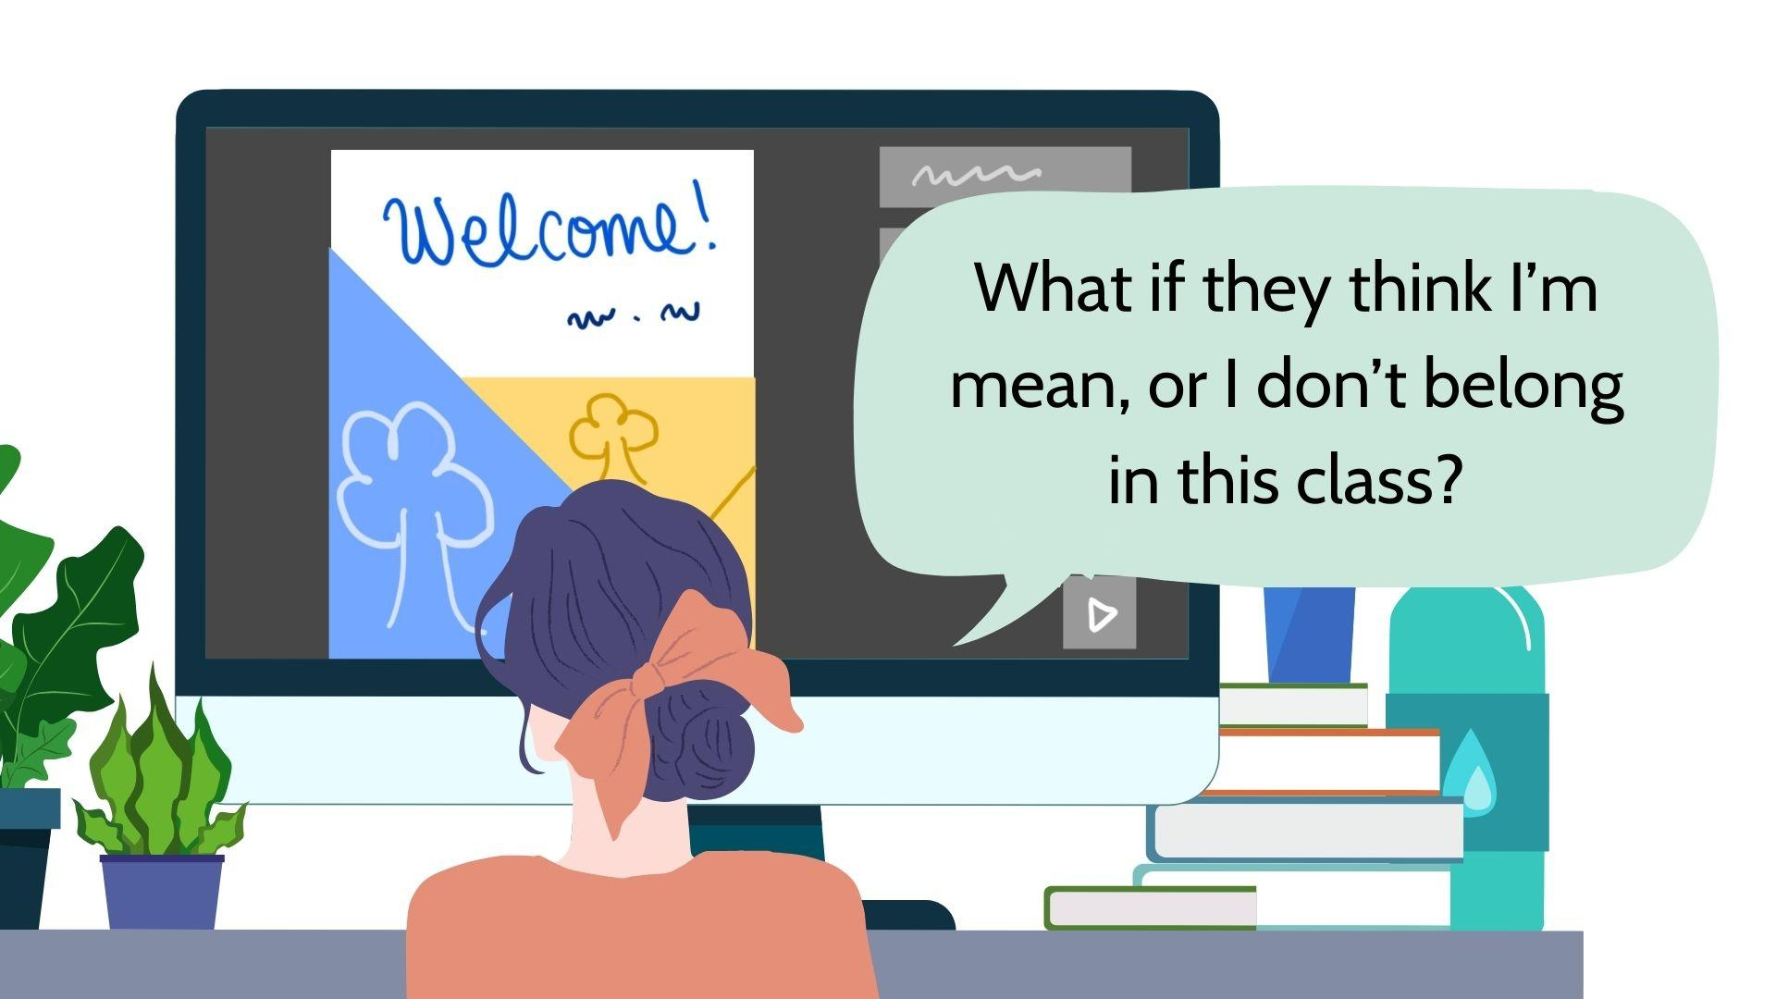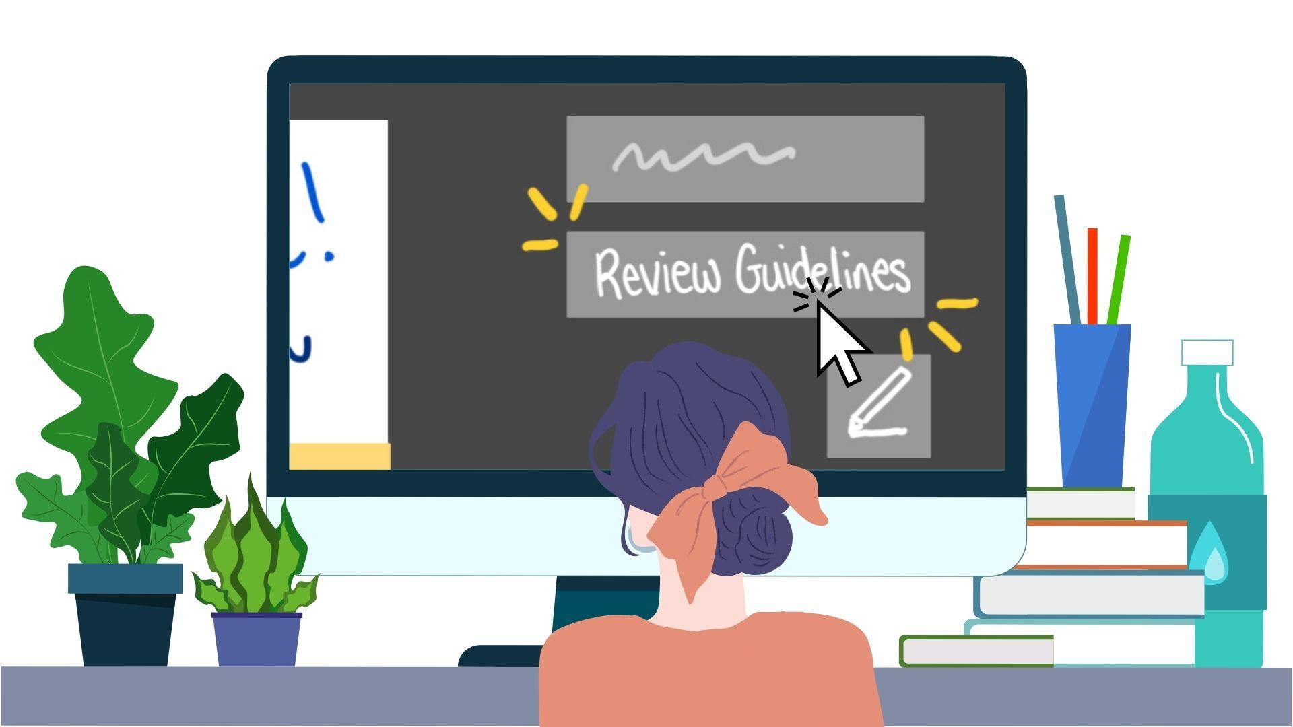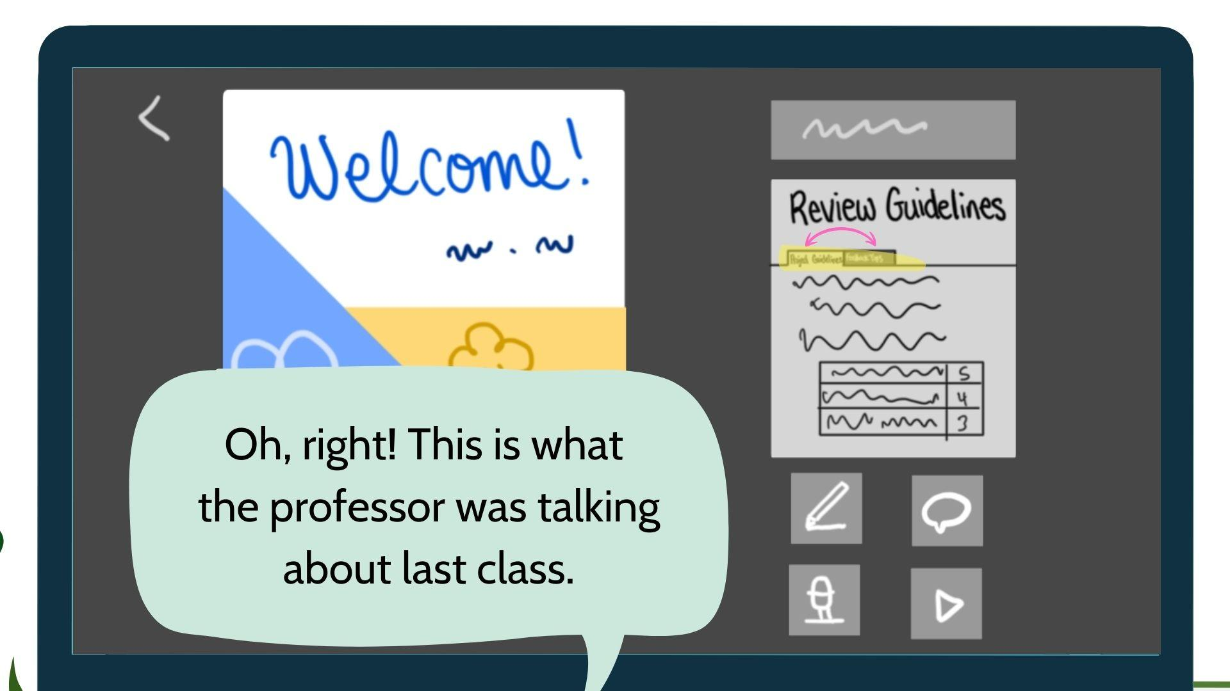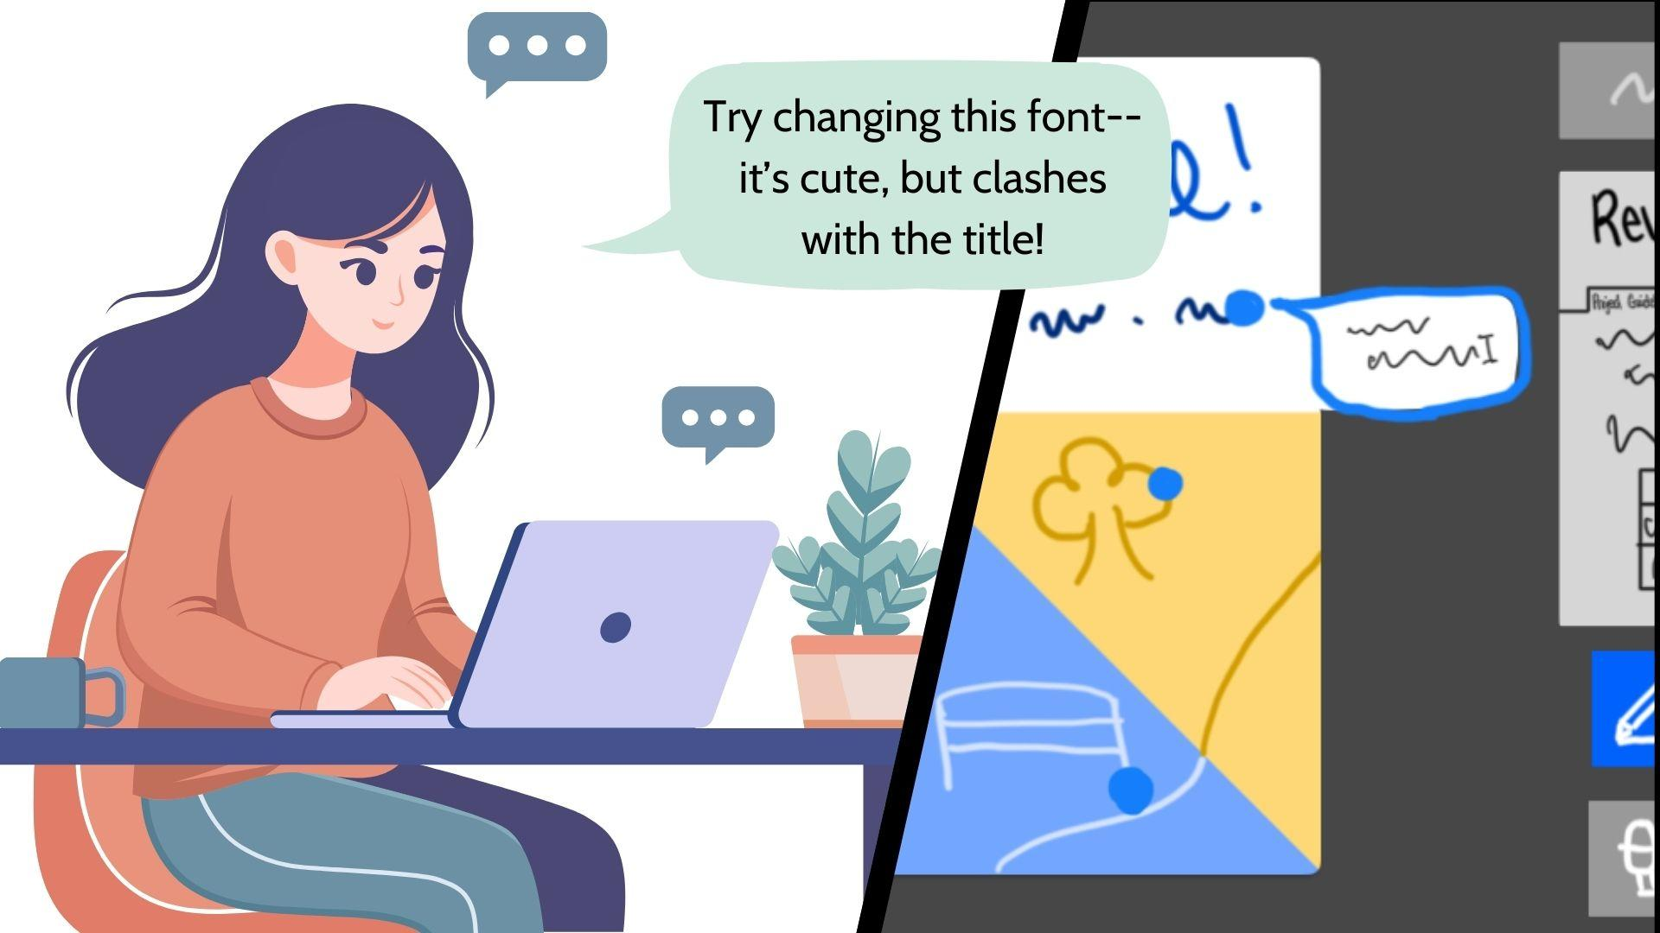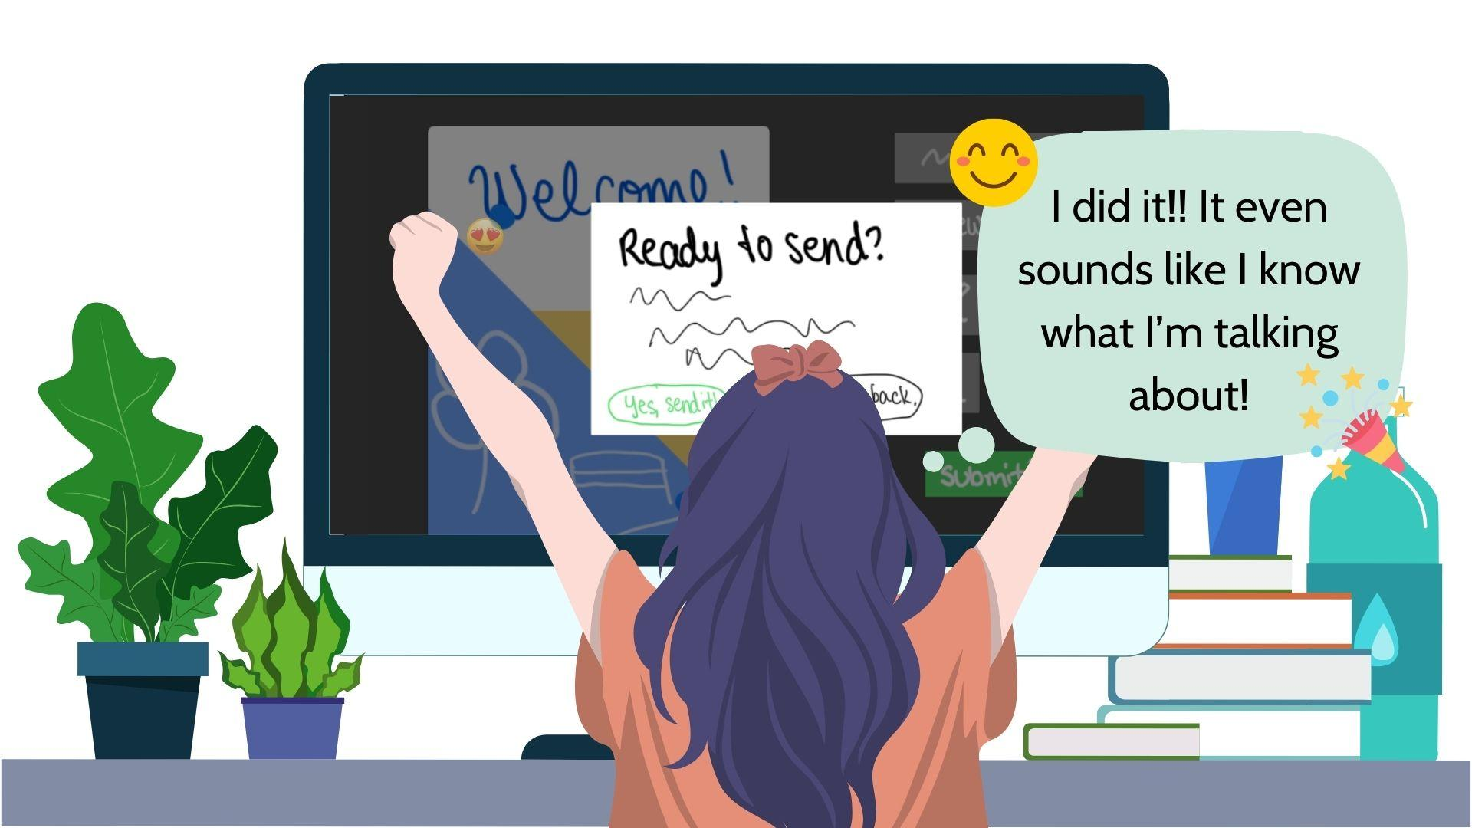

Scenario: Fret Struggles to Get the Feedback They Need!

Fret is a first-year art student who has just completed a design assignment. They’re eager to improve their design skills but are particularly nervous about certain elements of their work, such as the color choices in their artwork and the layout of their final composition. Although they are proud of their overall design, they feel unsure about how to address these focus areas without feeling vulnerable or asking too much of their peers.

A few days later, Fret receives two feedback comments: “I really like the overall design! It’s really creative and visually appealing.” and “I like the idea behind your design. It’s looking nice.”. One comment is a general compliment about the overall design while the other appreciates the idea but neither offers any advice on how to improve the color scheme or composition. This leaves Fret feeling uncertain about how to proceed and frustrated that their most important concerns weren’t addressed.

After this experience, Fret realizes their need to be more specific in their feedback requests. They revisit the platform, explore the receiving feedback page, and find a section that introduces the “Notes” feature. This tool allows users to leave sticky-note-like comments directly on their design, to point out specific areas for feedback. Inspired by the tool, Fret decides to be more specific in their next submission by asking directly for feedback on the areas they feel most uncertain about.

The next time Fret submits a design, they highlight the parts they’re concerned about, saying, “I’m not sure if the color palette is working well. Could you give me feedback on that?” and “Does this layout feel balanced to you?” This time, the feedback they receive is much more helpful. One peer suggests adjusting the contrast of the background to make the design stand out more, while another provides specific advice on rebalancing the layout to create a more 1
cohesive visual flow.

Through this experience, Fret now feels more confident in their ability to ask for and receive specific feedback that directly addresses the areas they want to improve.

Storyboard:

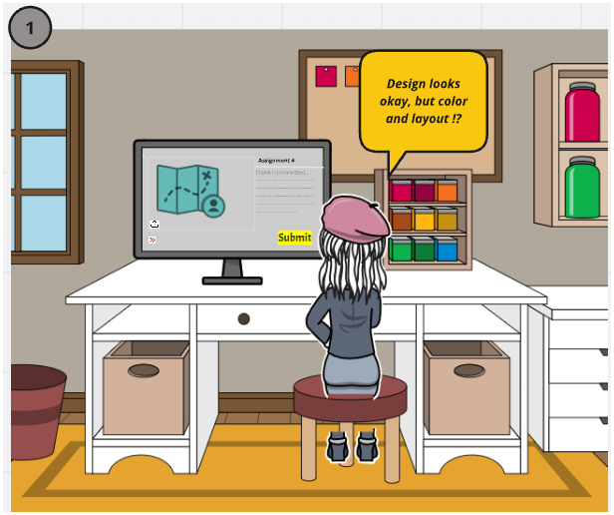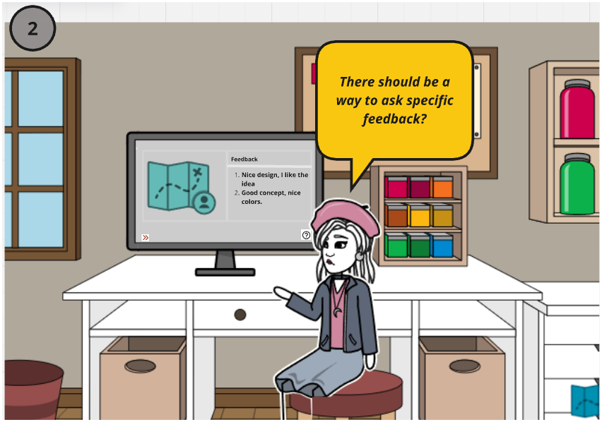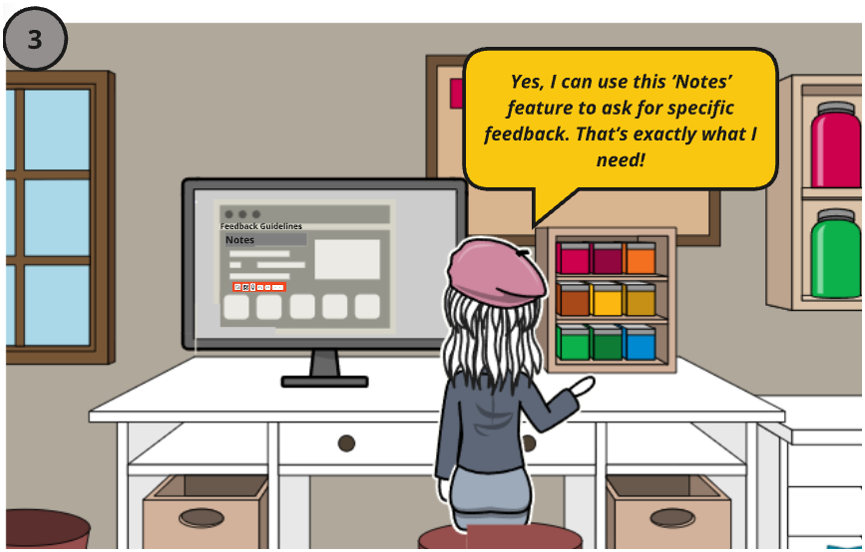
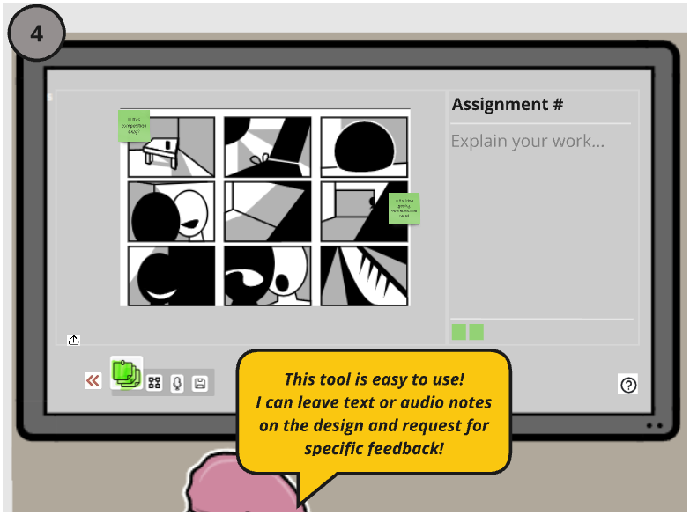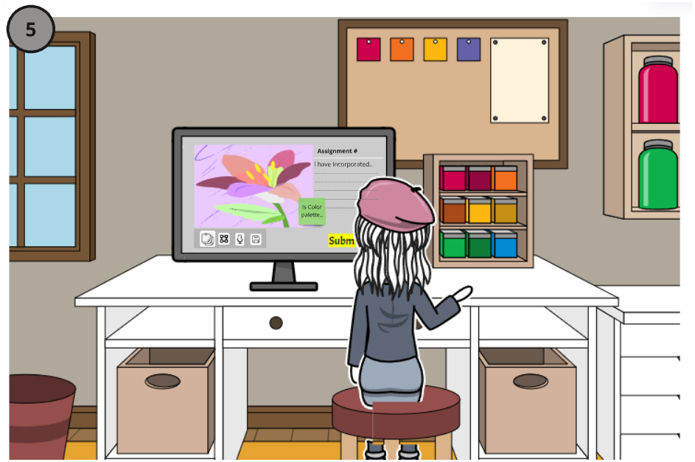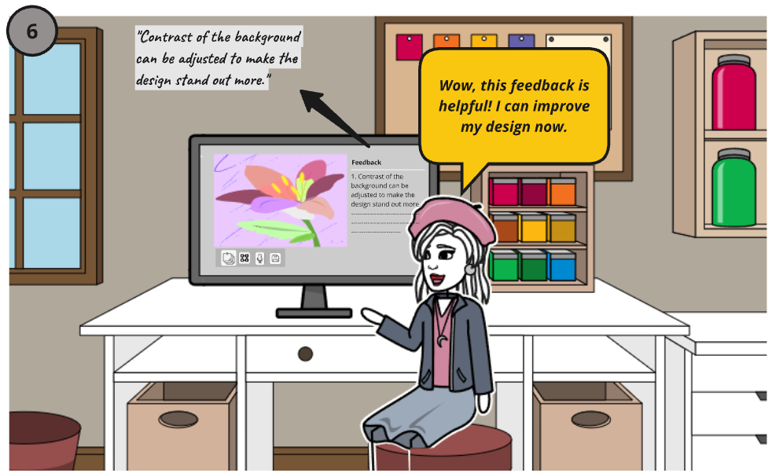

 | 
 | 
 | 

Scenario: Seasoned Hopes to Build a Long-Term Working Partnership Through Feedback
Seasoned, a UX design student, is juggling multiple projects and deadlines. They value building strong collaborative relationships with their feedback partner, but leaving thoughtful, detailed feedback keeps slipping their mind. They often forget when their partner has responded or when it is their turn to leave feedback. They feel frustrated about missing chances to engage meaningfully with their partner.

Scene 1: Struggling with overwhelm
Seasoned is sitting at their desk, surrounded by open tabs and notifications popping up on their laptop. They feel frustrated and stressed, thinking about how they keep forgetting to leave detailed feedback for their partner. Although they value collaboration and hope to build a strong working relationship, the workload and lack of reminders make it hard to stay on track.

Scene 2: Discovering a notification system
While exploring the course platform, Seasoned notices a new notification system that tracks feedback tasks. The system highlights when it is their turn to leave feedback and when their partner has responded. Feeling hopeful, Seasoned thinks this could finally help them stay on top of the feedback process and improve communication with their partner.

Scene 3: Using the notification system
Seasoned receives a notification that says, “Your partner responded to your feedback! View now.” Clicking the notification brings them directly to their partner’s response. They quickly read through it and feel encouraged to continue the exchange. The system’s simplicity helps them feel more connected and engaged with the process.

Scene 4: Giving feedback thoughtfully
Using the system’s built-in feedback guide, Seasoned starts leaving thoughtful and detailed feedback. The prompts help them focus on providing specific suggestions and constructive comments, making their feedback more meaningful. They feel a sense of accomplishment, knowing their partner will appreciate the effort.

Scene 5: Building a feedback rhythm
With regular notifications and a clear progress tracker, Seasoned and their partner establish a consistent rhythm for exchanging feedback. This structure makes the process feel manageable and rewarding, helping them stay motivated. Seasoned feels more confident in their ability to maintain a collaborative partnership.

Scene 6: Achieving a partnership
Seasoned and their partner are on a video call, discussing their project and reflecting on their progress. A summary of their feedback exchanges on the screen highlights how their collaboration has grown. Seasoned feels proud of the strong partnership they have built and excited about working together in the future.

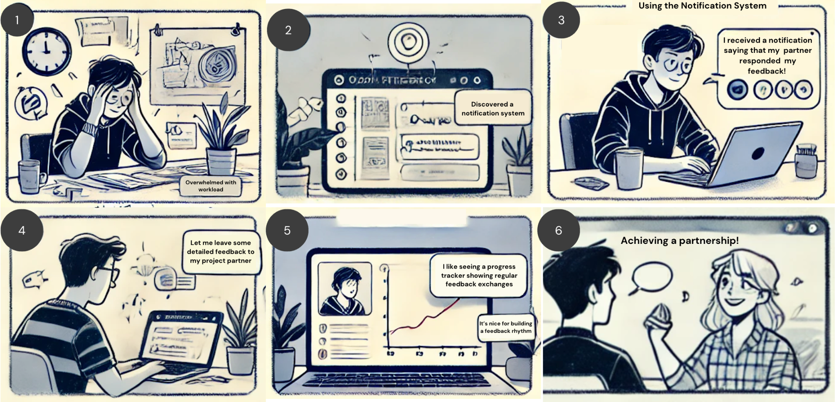

Scenario: Seasoned can’t interpret tone of written feedback

UX Action
Choosing the type of feedback they want to leave (text (written), voice note (audio) etc.) Lee, a UX design student needs to leave recorded commentary in order to add more clarity and depth to his feedback without worrying about having his words and tone misinterpreted.

One-sided
Seasoned, is in her final year of college and occasionally struggles to interpret the tone of written comments from her class partners, especially when sometimes feedback comes across as stern or unfriendly in his written comments. This becomes an issue when she has to collaborate on complex projects requiring feedback on multiple touchpoints of design work. To minimize miscommunication, Seasoned prefers face-to-face interactions, either in class or over Zoom.
Her partner is unaware that his feedback can be met with resistance or confusion, yet he stands by his opinions, even when they aren’t received as he intended. Seasoned has acknowledged their communication challenges, and is eager to find better ways to collaborate effectively.
Seasoned partner will be traveling home for the next two weeks and attending class remotely. They both decided that leaving voice notes on each other’s work would be the best way to maintain clarity and context during their time apart. Seasoned is excited to try this approach, but they also recognize the need to easily pinpoint specific design elements in their project to provide additional options for feedback, such as written comments.
Storyboards
Scene 1: Seasoned’s UX Design Partner is providing text-based feedback on a group project. He writes with confidence and doesn’t focus on crafting a friendly tone. While some of his feedback is vague, it often comes across as assertive.
Scene 2: Seasoned receives a notification that her partner has left feedback on their group project. However, she finds one of his comments confusing and is taken aback by the assertive tone. She wishes she could better understand his intent to avoid feeling embarrassed.
Scene 3: Because their communication styles are so different, she asks her partner to meet in person in their advanced UX Design class. This approach is much better because of language and tone barriers.
Scene 4: Seasoned’s partner informs her that he’s leaving for two weeks and will be attending class remotely. The brainstorm how to keep in contact because the project is due as soon as he returns from visiting his family. They decide at a team to try audio recording and transcripts to better understand each others feedback.
Scene 5: As the project progresses over the next week, Seasoned’s partner sends her audio feedback from his parent’s house.
Scene 6: Seasoned gets to hear recorded audio feedback and she is relieved to know they are both aligned on their project and agree with their visual and UX approaches.

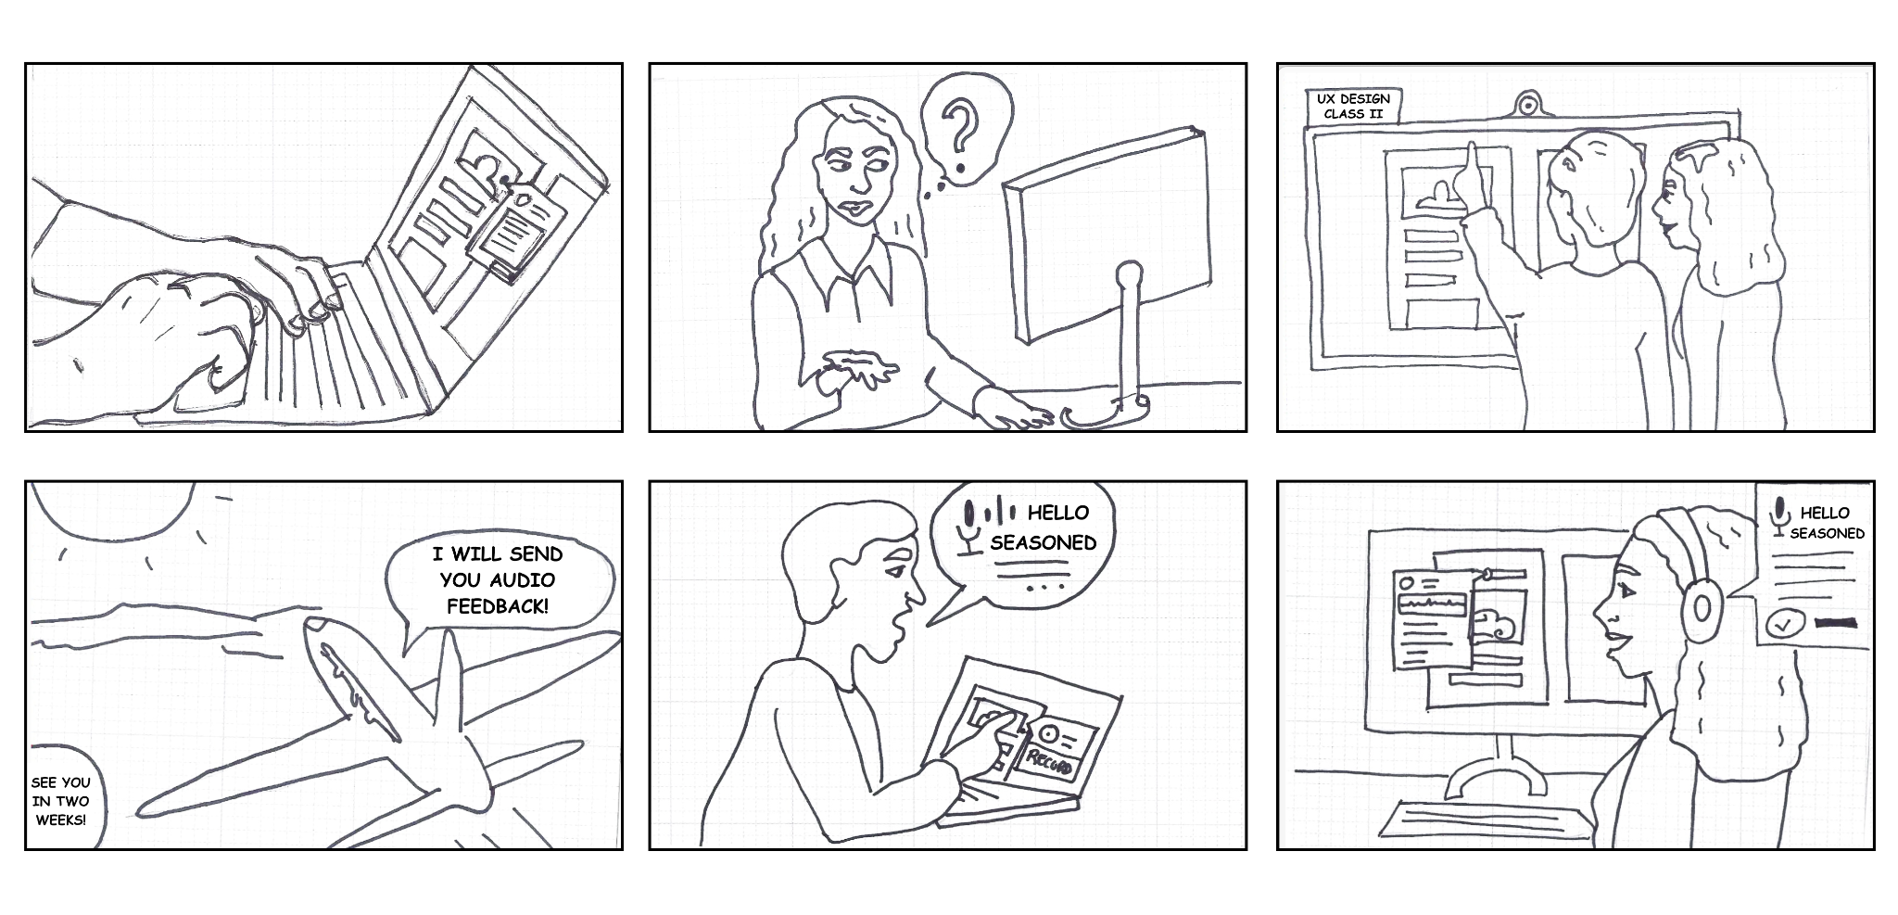

Alternative Two-sided scenario
Seasoned, in her final year of college, occasionally struggles to interpret the tone of written comments from her class partners, Lee, especially when they are collaborating on complex projects requiring feedback on multiple touchpoints. To minimize miscommunication, she prefers face-to-face interactions, either in class or over Zoom.
Lee, also a senior and a UX Design student, is experienced in providing feedback but sometimes comes across as stern or unfriendly in his written comments. He’s aware that his feedback can sometimes be met with resistance or confusion, yet he stands by his opinions, even when they aren’t received as he intended. Acknowledging their communication challenges, both are eager to find better ways to collaborate effectively.
With Lee traveling home for the next two weeks and attending class remotely, they’ve decided that leaving voice notes on each other’s work would be the best way to maintain clarity and context during their time apart. Both are excited to try this approach, but they also recognize the need to easily pinpoint specific design elements in their project to provide additional options for feedback, such as written comments.

